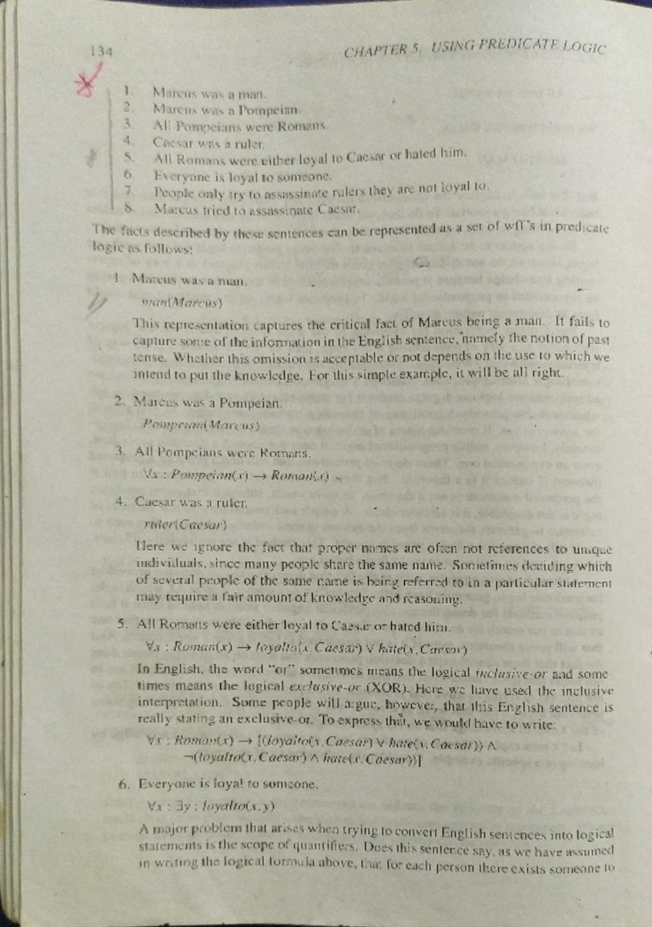

134

1.

2.

3.

4.

5.

6.

7

Marcus was a man.

Marcus was a Pompeian.

All Pompeians were Romans.

Caesar was a ruler.

CHAPTER 5, USING PREDICATE LOGIC

All Romans were either loyal to Caesar or hated him. Everyone is loyal to someone.

People only try to assassinate rulers they are not loyal to.

8. Marcus tried to assassinate Caesar.

The facts described by these sentences can be represented as a set of wff's in predicate logic as follows!

1. Marcus was a man.

man Marcus)

This representation captures the critical fact of Marcus being a man. It fails to capture some of the information in the English sentence, namely the notion of past tense. Whether this omission is acceptable or not depends on the use to which we intend to put the knowledge. For this simple example, it will be all right.

2. Marcus was a Pompeian.

Popean Marcus)

3. All Pompeians were Romans.

Nx: Pompeian(x) →Roman

4. Caesar was a ruler.

ruter(Caesar)

Here we ignore the fact that proper names are often not references to unique individuals, since many people share the same name. Sometimes deciding which of several people of the same came is being referred to in a particular statement may require a fair amount of knowledge and reasoning.

5. All Romans were either loyal to Caesar or hated him.

Vx: Roman(x). ->>> loyaltala. Caesar) v kateis, Caesar)

In English, the word "or" sometimes means the logical inclusive-or and some- times means the logical exclusive-or (XOR). Here we have used the inclusive interpretation. Some people will argue, however, that this English sentence is really stating an exclusive-or. To express that, we would have to write: Vx: Roman(x)(loyaltos Caesar) hate. Caesar))

(toyaltox, Caesar) inatetr. Caesar))

6. Everyone is loyal to someone.

Va: 3y: loyalto(x,y)

A major problem that arises when trying to convert English sentences into logical statements is the scope of quantifiers. Does this sentence say, as we have assumed in writing the logical formula above, that for each person there exists someone to